Can Stock Prices Be Predicted?

ST462 Advanced Regression Project

Jaden Kwek

Carson Boettinger

Table of Contents

Introduction 2

Data Description 3

Exploratory Data Analysis 6

Confirmatory Data Analysis 8

Final Conclusions and Discussions 14

References 15

# 

# **Introduction**

Predicting stock prices has long been an intriguing and complex challenge that draws upon various financial indicators and economic factors. With the surge of quantitative finance, the application of statistical models like regression analysis to forecast stock prices has gained substantial momentum. This project is poised at the intersection of financial analysis and regression modeling, aiming to discern the underlying patterns within historical financial data to anticipate future stock price movements. Through extraction and examination of key financial metrics, we aim to construct a regression model that harnesses fundamental stock analysis instead of technical analysis. By leveraging such a model, we aim to unveil insights that could potentially lead to more informed investment decisions, contributing to modern financial analytics.

**Objectives of the Study**

If anyone could accurately predict the stock market, they’d be the richest person in the world. Thus, this study is not focused on predicting stock prices just from looking at a chart. Instead, it is focused on predicting stock prices from looking at company data such as revenue, profitability, margins, and debt, while also taking into account macroeconomic factors such as the unemployment rate, risk free interest rate, and inflation. This study has two main objectives:

1. To determine how various financial data metrics affect companies and their stock prices on a whole, individually, and depending on their industry
2. To create a regression model that takes all these relationships into account and can predict a stock’s price for a future quarter based on the company’s financial estimates for the supposed quarter, as well as future economic data estimates

# **Data Description**

Our task after setting these goals was to find stock price data along with company financials and economic data in a time series format. Initially, we tried searching for stock price data exclusively on Kaggle, but ended up with a dataset that was far too complicated and large to use, since it contained the daily stock prices of every single company on the U.S. stock market for over 10 years. This did not encompass any financial data information so we decided to pivot and collect our own data manually. Using S&P’s CapitalIQ Microsoft Excel Plugin, we manually used built in CIQ Excel formulas to create a dataset of our own, collecting data points such as stock price, total revenue, primary industry, etc. for all S&P 500 companies for the past20 quarters (Q4 2023 - Q1 2019).

Figure 1.0: CapitalIQ’s Excel Formula Builder

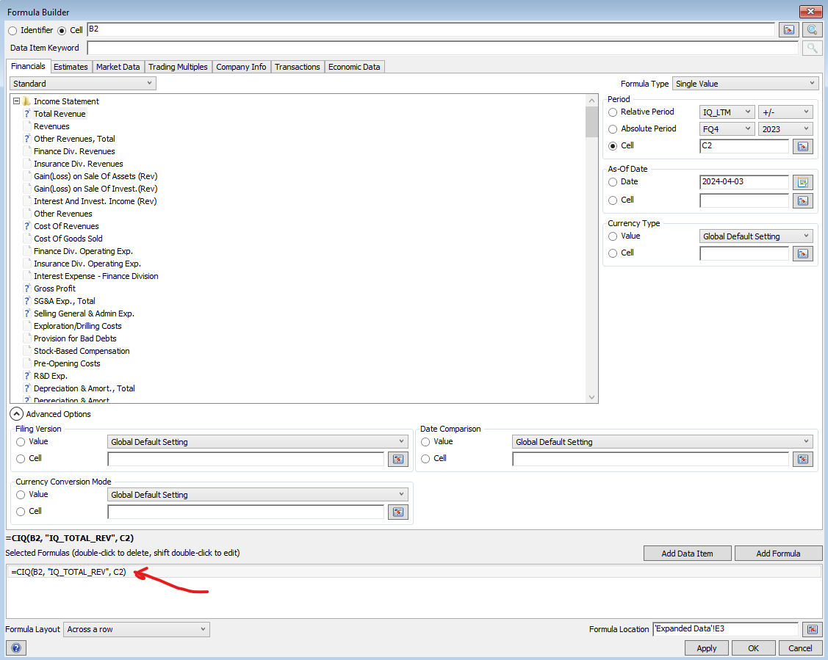

As seen in the image above, various data points can be collected and in this case **total revenue** is being retrieved for the **company ticker** referenced by cell B2 at **Q4 2023** referenced by cell C2. This process was repeated for all the metrics we thought would be important for the study. After our manual data collection, we ended up with a dataset containing 9981 rows and 23 columns which boils down to **499 companies** being analyzed for 20 time periods each with 18 variables at each time period. This initial dataset contained issues such as NA values for companies whose debt/equity for example was negative for a certain quarter (CIQ displays this as NA instead of a negative number), so our data was then cleaned by removing any row containing an NA value. For importing the dataset into Python and R, the CIQ formulas also had to be dropped so we also turned the xlsx file into a csv. Lastly, 4 new columns were added to the dataframe: Year, Last Price Baseline Change, Revenue Baseline Change, and EBITDA Baseline Change. Here is a description of the most important variables in our final dataset (see Figure 1.5 in the appendix for a full list and descriptions):

| **Variable Name** | **Description** | **Example** |
| --- | --- | --- |
| Company Name | The name of the company being analyzed | “3M Company” |
| Period Ending | The specific quarter being analyzed, 20 quarters per stock | “FQ42023”, “FQ32023”, etc |
| Last Sale Price | The closing stock price of the company corresponding to their fiscal quarter end date | “109.32” corresponding to 2023-12-31 |
| Revenue ($M) | Quarterly revenue for the company for the selected quarter in millions of dollars | “8013” corresponding to 3M’s FQ42023 results |
| Gross Profit Margin | Quarterly gross profit margin (expressed in a decimal number between 0 and 1), multiply by 100 to get the gross profit margin % $Gross Profit/Revenue$ | “0.420441”, or 42.04% |
| Normalized Net Income ($M) | This is what the net income ‘should’ be as it removes one time accounting events and non-recurring items that wouldn’t normally be part of business operations | “463.625” or $463.6 million dollars |
| Normalized Net Income Margin | Same format as gross profit margin $Normalized Net Income/Revenue$ | “0.057859”, or 5.7859% |
| Primary Industry | The main industry that the company operates in | “Specialty Chemicals”, “Pharmaceuticals”, “Biotechnology” |
| Debt to Equity | The debt/equity ratio for the selected company for the specific quarter | “3.480279” for 3M Company for FQ42023 |
| Current Ratio | Current Assets/Current Liabilities for the selected company and quarter | “1.07073” |
| US YOY CPI | The year over year inflation rate at a selected month and year | “0.0335212”, or 3.35% year over year inflation in Dec-23 |
| Unemployment Rate | The unemployment rate at a selected month and year | “0.037”, or 3.7% in Dec-23 |
| Fed Funds Rate | The U.S. overnight risk-free interest rate at a selected date | “0.0533”, or 5.33% at 2023-12-31 |
| Last Sale Price Change From Baseline (%) | For each company, sets the last sale price for the first quarter (FY2019) equal to 0 and each price after that relative to its 2019 value. Expressed in percentage points.  Understanding this variable is **crucial** for interpreting the results of the study. | “-47.38665897”, or in FQ42023 3M’s stock price was 47.39% lower than what is was in FQ12019 |

Now that the important variables in the dataset have been explained, we will now move onto exploring the relationship between the last sale price and the rest of the variables.

# **Exploratory Data Analysis**

Figure 1.1: Correlations on an Industry Basis

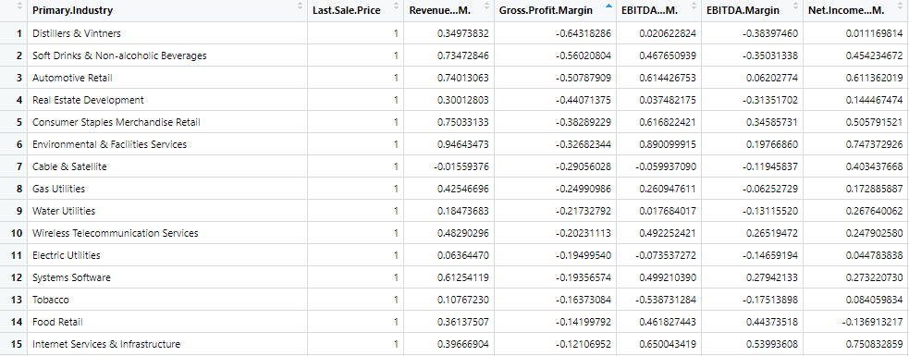

Figure 1.2: Correlation Matrix for all Companies on Average

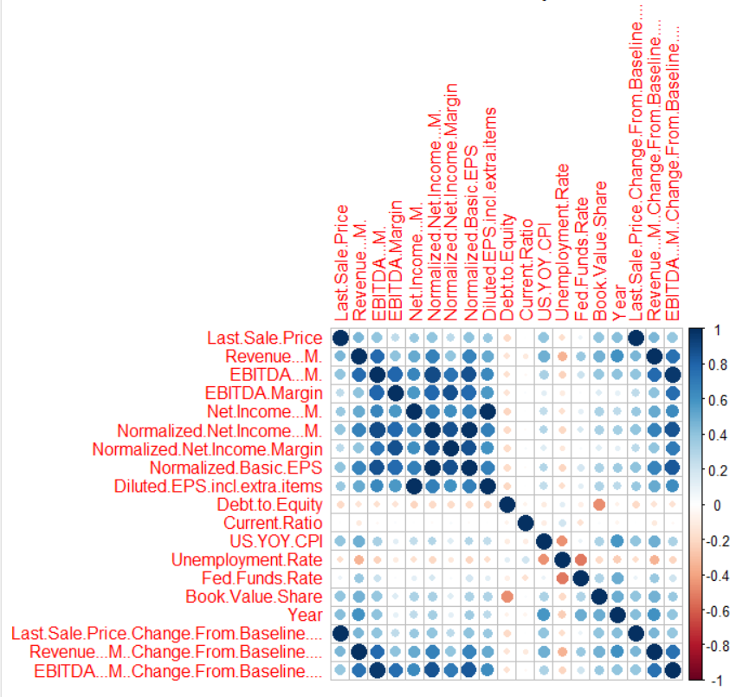

After performing EDA, we discovered that in various industries variables can affect stock price more than others. Looking at Figure 1.1 above, some interesting findings here are negative correlations between stock prices and gross profit margins for a few industries including distillers, soft drinks, and automotive retail which is interesting because the effect we would normally assume is positive. This negative correlation may be associated with these companies being measured on market penetration/share instead of profitability which would put pressure on margins.

As shown in Figure 1.2 above, plenty of variables from the dataset are intercorrelated, specifically financial variables such as revenue, EBITDA, and net income, along with their margins, which makes sense. At the same time, some variables are negatively correlated with each other like the unemployment rate and the Fed Funds rate, which is interesting because normally you would expect higher interest rates to lead to higher unemployment, but there is a lag factor as COVID-19 caused high unemployment and then rates dropped, but as employment recovered the Fed decided to increase rates to combat inflation, so this makes intuitive sense.

Focusing on the last sale price variable specifically, on average most variables seem to be positively correlated with it but the correlations are company dependent. If you look at Figure 2.0 from the appendix, you’ll see that for the company 3M their current ratio had a strong positive correlation with their stock price but the Federal Reserve Funds Rate had a strong negative correlation. This demonstrates that every single company in the S&P 500 will have different weights for how these variables are related to their last sale price.

Moving onto trends specific to the variables themselves, as seen in Figure 1.7 in the appendix there is variance in how the businesses time their quarterly reporting. For example, there are fewer spaghetti lines from the year 2018 because of the difference in reporting periods of companies (majority of companies’ Q1 2019 is set in 2019, not 2018). To ensure our model does not mix up dates and quarters, we used the Capital IQ plugin to extract the actual date from the quarters for each company and link that to economic data like CPI and the Fed Funds rate so the modeling for the irregular companies whose Q1 2019 is actually in 2018 have accurate economic information from 2018.

Lastly, after examining boxplot Figure 1.8 in the appendix we found there is a scarcity of outliers, likely due to the limited time frame of 2018-2023, which fails to capture significant financial fluctuations such as large crises and booms. ⁤⁤However, there is a lone outlier on the lower end of some variables like Gross Profit Margin, EBITDA Margin, and Normalized Net Income Margin which indicate a business with irregularly high operating expenses and cost of goods sold. This outlier is likely attributed to companies who had to pause operations during the COVID-19 pandemic. The extreme outlier for unemployment rate was also most likely because of this.

⁤Interestingly, despite theoretical possibilities, federal reserve interest rates hover at zero, never falling below it or breaking it. The reason for this is that inflation is meant to be at 1-3% and going into negative interest rates means a lot more borrowing as you are given money to borrow and inflate the economy by a large margin. Other than these findings, the figures display standard values with no significant deviations.

# **Confirmatory Data Analysis**

After reviewing the correlations between every variable, we then grouped the data into Level 1 and Level 2 variables. The initial variables we thought of using can be seen in Figure 1.6 in the appendix but for the final model we settled on 7 variables total as seen below.

| **Variable (s)** | **Additional Details** |
| --- | --- |
| Last Sale Price Change From Baseline (%) | Level 1, Response Variable |
| Period Ending | Level 1, Individual Observations |
| Revenue | Level 1 |
| Debt to Equity | Level 1 |
| CPI | Level 1 |
| Fed Funds Rate | Level 1 |
| Company Name | Level 2, Grouping Factor |

Initially, we began with a basic unconditional means model deemed Model A which only contained random effects including the intercept and the residual and one fixed effect being the intercept. Both effects had extremely high variances, suggesting that there are large differences in variation between companies when it comes to stock price movements. We manually calculated that 60% of total variation in stock price levels is attributable to differences between companies rather than changes over time in the same company, which made intuitive sense.

Moving on from there, we constructed Model B which was an unconditional growth model which added Period Ending as a level 1 variable which was incredibly significant to the model and its estimate of 4.1304 suggested that on average with all else being equal stock prices increased 4% each quarter (simple, not compounded) from 2019 to the end of 2023.

Model C involved adding the second level 2 variable Industry as we learned from EDA that every industry has different slopes for their level 1 variables. However, given the companies themselves each have their own slopes for each variable, adding industry just complicated the model and resulted in a higher AIC BIC for Model C over B.

From Model D to I, various level 1 variables were tested but the dataset had to be modified once more as R was running into issues due to some variables being so much larger than others that fitting became impossible (ex: revenue is in millions compared to US CPI which is a percentage generally less than 10%). This problem was solved by rescaling each variable that wasn’t a percentage into a value between 0 and 1, with 1 representing the maximum of that variable for each company and every other value in that variable’s column being relative to that. Period Ending was also converted to the numbers 0 - 19 to account for each of the 20 quarters per company instead of FQ12019, FQ22019…etc which R interpreted as categories. After adding and subtracting multiple variables and interaction terms into potential models, we settled on Model F in which the full equation is written for here:

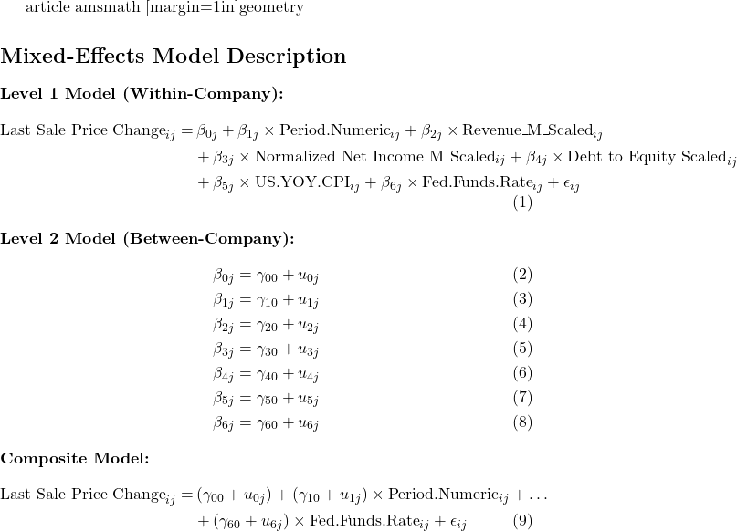

Every variable included in Model F was statistically significant, except for CPI which actually had a t-value below |2|, but removing CPI only increased AIC and BIC, so including it in the model was the optimal choice. Higher inflation leading to higher prices are expected to have a positive effect on the profit of businesses so including CPI makes logical sense. In addition, interaction effects were tested (although R had trouble fitting with this) but we did not see any that ended up becoming statistically significant despite the intuitive opinion that they would, so our final model ended up with no interaction effects. The results of the fitted model make intuitive sense and the interpretation of each fixed effect is as follows:

| **Fixed Effect** | **Estimate** | **Interpretation** |
| --- | --- | --- |
| Intercept | -9.815 | With all else being zero, the baseline price of a stock is 9.8% lower than what it actually was in Q1 2019. This makes sense because revenue is never 0 in the data since it’s all relative to the maximum value during the 20 quarters. |
| Period Ending | 3.743 | All else being equal, over time stock prices increased 3.7% every quarter (simple not compound interest) from their base 2019 levels. This makes sense because the entire stock market increased in the last 4 years quite significantly. |
| Revenue Scaled | 35.850 | Increasing revenue scaled by 1, or increasing a company’s quarterly revenue by whatever the maximum value was during the 20 quarter period will boost the stock price by 35.85% (relative to 2019 levels). We feel this estimate is quite conservative and in reality the boost would be much higher, and we’ll see this later when we look at the diagnostic plots. |
| Normalized Net Income Scaled | 11.577 | Increasing normalized net income by 1 (same format as revenue scaled) results in an 11.6% stock price boost. Again, we feel this estimate is overly conservative. |
| Debt to Equity Scaled | -14.995 | Increasing the D/E ratio by whatever its maximum value was in the 20 quarter time period results in a 15% decrease in the stock price. We feel this estimate is also too conservative as more than doubling D/E would likely cause a larger dive than that. |
| CPI | 49.263 | Increasing the CPI level by 100% (unrealistic except for in Zimbabwe, typical data in the chart is 1-9%) YOY in a given quarter results in a 49% stock price increase from 2019 levels. This makes sense if you reframe this from the perspective of if you increase CPI by 1%, stock prices increase 0.49%. Generally speaking, higher inflation leads to higher prices, including the values of stocks. |
| Fed Funds Rate | -456.379 | Increasing the interest rate by 100% (unrealistic, fed funds rate is normally 0-5%) results in a massive drop in stock price. When reframing this to the perspective of increasing the interest rate by 1% drops stock prices by 4.56% on average, it makes intuitive sense because stock prices are negatively correlated with the risk free rate. |

Looking at the correlations of all the effects, there weren’t any notable correlations among the fixed effects but there were among the random effects. The key correlations here were revenue having a 0.74 correlation with net income, CPI having a 0.74 correlation with net income, and fed funds rate having a -0.8 and -0.74 correlation with revenue and net income, and a 0.87 correlation with debt to equity. To summarize the interpretation of this, within companies we see that the slope for revenue and CPI is highly correlated with net income which makes sense since higher CPI leads to higher inflation thus higher prices, higher revenues, and therefore higher net income. On the flip side, a higher fed funds rate leads to lower revenue, net income but a higher debt to equity which also makes intuitive sense because a higher rate reduces the money supply in the economy while also driving up the cost of debt, thus leading to lower consumer spending and therefore lower revenue and net income, while debt becomes harder to pay off leading to higher debt/equity.

Moving onto model diagnostics now, for the vast majority of data points the fit is very good, with a relatively low number of outliers in the 8665 data points. The x-axis represents the response variable which is each observation of the change in baseline price from 2019 for every stock and it is evident that while the model is very strong when it comes to stocks that did not increase or decrease dramatically from Q1 2019 - Q4 2023, for stocks that skyrocketed or crashed throughout the 4 years the model is ineffective at predicting this.

Figure 1.3: Pearson Residual Plot of Model F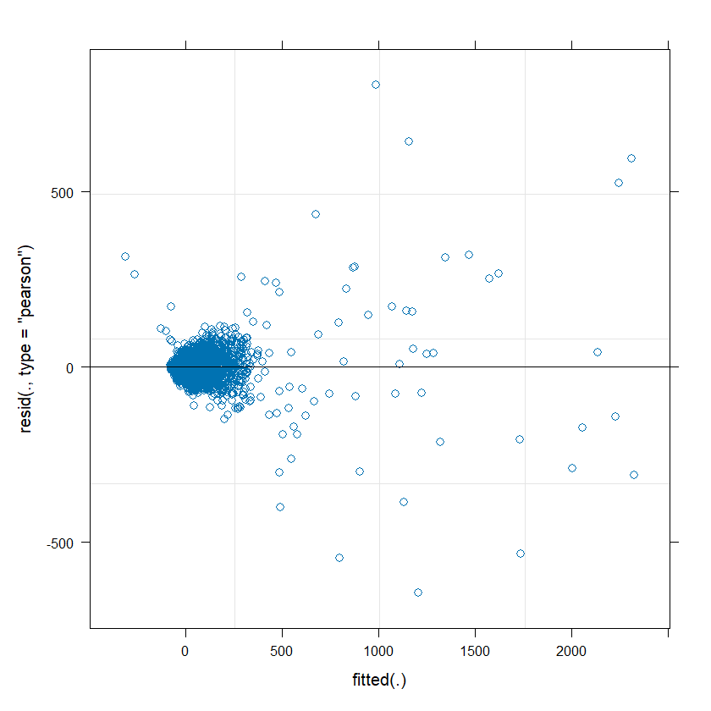

Moving onto the distribution of the random effects, all appear to be normally distributed but some effects have more outliers than others, particularly on the tail ends. Since our model assumes that these effects follow a normal distribution, the outliers at the tail ends are why our model fails to predict large stock price increases and decreases and therefore has conservative coefficients for variables like revenue, net income, and debt/equity. Using a t-distribution for these effects in the future may result in a more accurate model that accounts for fat tails.

Figure 1.4: QQ Plots for Random Effects in Model F

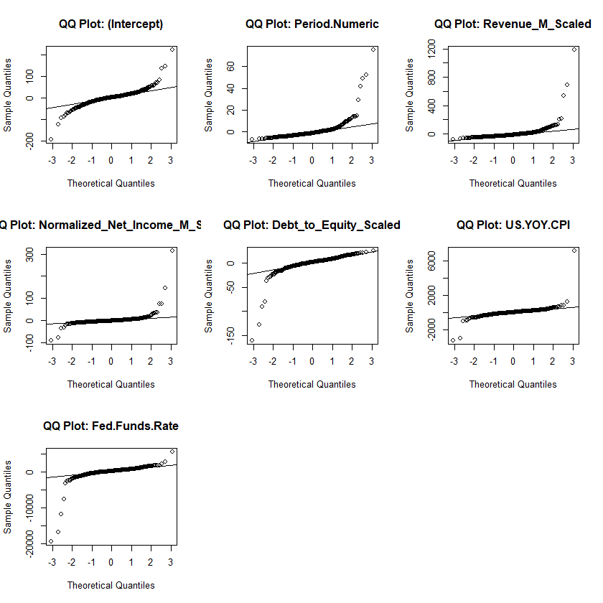

# **Final Conclusions and Discussions**

The model that was generated to predict a company’s stock price relative to its Q1 2019 data has proved to be quite effective for the majority of companies, but becomes inaccurate when trying to predict large stock increases (beyond a few hundred percent) and decreases (above 50%). This is likely due to the normal distribution of the random effects and the period of reporting of where we are capturing price being more volatile as quarterly reporting dates introduce more information which adjusts future expectations. Adding a GARCH (Generalized AutoRegressive Conditional Heteroskedasticity) model for volatility into the model in the future could help capture some of this variability in stock price jumps during these periods. Moreover, the mixed-effects model used in this analysis helps account for individual company variability through random effects, but it does not account for all types of nonlinearities or external market forces that can affect stock prices. Factors such as market sentiment, unexpected economic news, and global events can cause stock prices to deviate significantly from the trends captured by financial data alone.

In the field of financial time series forecasting, where accuracy is paramount, an ensemble of different models may be the best approach. Combining linear regression models like this one with neural network models could leverage the strengths of each method, potentially providing a more robust and accurate prediction system for stock prices. Overall, while the current model offers valuable insights and satisfactory predictions for a range of scenarios, a multifaceted modeling approach may be more effective in capturing the complex dynamics of the stock market and providing more reliable predictions, especially for outlier events with significant price changes.

# 

# **References**

S&P Capital IQ. (2024). Retrieved April 3rd, 2024, from S&P Capital IQ Excel Plug-in.

# 

# 

# 

# 

# 

# 

# 

# 

# 

# 

# 

**Appendix**

Figure 1.5: Information on All Variables in the Dataset

| **Variable Name** | **Description** | **Example** |
| --- | --- | --- |
| Company Name | The name of the company being analyzed | “3M Company” |
| Ticker | The ticker corresponding to the name of the company | “NYSE:MMM” |
| Period Ending | The specific quarter being analyzed, 20 quarters per stock | “FQ42023”, “FQ32023”, etc |
| Month and Year | Since each company has a different fiscal quarter, this identifies the corresponding month and year | “Aug-23” corresponding to FQ42023 (this is irregular, most companies correspond to Dec-23) |
| Corresponding Date | Adds the corresponding date to the month and year column | “2023-08-31” |
| Last Sale Price | The closing stock price of the company corresponding to their fiscal quarter end date | “109.32” corresponding to 2023-12-31 |
| Revenue ($M) | Quarterly revenue for the company for the selected quarter in millions of dollars | “8013” corresponding to 3M’s FQ42023 results |
| Gross Profit Margin | Quarterly gross profit margin (expressed in a decimal number between 0 and 1), multiply by 100 to get the gross profit margin % | “0.420441”, or 42.04% |
| EBITDA ($M) | Same format as revenue | “1550” |
| EBITDA Margin | Same format as gross profit margin | “0.14102” |
| Net Income ($M) | Same format as revenue | “945” |
| Normalized Net Income ($M) | This is what the net income ‘should’ be as it removes one time accounting events and non-recurring items that wouldn’t normally be part of business operations | “463.625” |
| Normalized Net Income Margin | Same format as gross profit margin | “0.057859” |
| Normalized Basic EPS | Normalized Net Income/Number of Outstanding Shares, expressed in dollars | “0.83581” ($0.84 earnings per share) |
| Diluted EPS Including Extra Items | Similar to Basic EPS but uses net income instead of normalized net income and divides it by shares + dilutive shares (shares that could be created from conversions such as options or convertible bonds) | “1.70022” |
| Primary Industry | The main industry that the company operates in | “Specialty Chemicals”, “Pharmaceuticals”, “Biotechnology” |
| Debt to Equity | The debt/equity ratio for the selected company for the specific quarter | “3.480279” for 3M Company for FQ42023 |
| Current Ratio | Current Assets/Current Liabilities for the selected company and quarter | “1.07073” |
| EBITDA/Interest Expense | Quarterly EBITDA/Quarterly Interest Expense for the selected company and quarter - this measures the company’s ability to pay down its debt | “4.45148” |
| US YOY CPI | The year over year inflation rate at a selected month and year | “0.0335212”, or 3.35% year over year inflation in Dec-23 |
| Unemployment Rate | The unemployment rate at a selected month and year | “0.037”, or 3.7% in Dec-23 |
| Fed Funds Rate | The U.S. overnight risk-free interest rate at a selected date | “0.0533”, or 5.33% at 2023-12-31 |
| Book Value/Share | The company’s common equity value divided by the number of outstanding shares, expressed in dollars | “8.69917”, or $8.70 per share |
| Year | Just the year | “2023” |
| Last Sale Price Change From Baseline (%) | For each company, sets the last sale price for the first quarter (FY2019) equal to 0 and each price after that relative to its 2019 value. Expressed in percentage points.  Understanding this variable is crucial for interpreting the results of the study. | “-47.38665897”, or in FQ42023 3M’s stock price was 47.39% lower than what is was in FQ12019 |
| Revenue ($M) Change From Baseline (%) | Same format as Last Sale Price Change From Baseline (%) | “1.907668829”, or 3M’s FQ42023’s revenue was 1.91% higher than FQ12019’s |
| EBITDA ($M) Change From Baseline (%) | Same format as Last Sale Price Change From Baseline (%) | “-25.73071394”, or 3M’s FQ42023’s EBITDA was 25.73% lower than FQ12019’s |

Figure 1.6: All Variables Considered when Building the Model (this led to the model taking an infinite amount of time to fit)

| **Variable (s)** | **Additional Details** | **Correlated Variables** |
| --- | --- | --- |
| Last Sale Price Change From Baseline (%) | Level 1, Response Variable | All Variables |
| Period Ending | Level 1, Individual Observations | N/A |
| Revenue, EBITDA, Normalized Net Income, Gross Profit Margin, EBITDA Margin, Normalized Net Income Margin | Level 1 | Eachother |
| Debt to Equity, Book Value/Share | Level 1 | Eachother |
| Current Ratio | Level 1 | N/A |
| Unemployment Rate | Level 1 | CPI, Fed Funds |
| CPI, Fed Funds | Level 1 | Unemployment Rate |
| Company Name | Level 2, Grouping Factor | All Variables |
| Primary Industry | Level 2 | All Variables |

Figure 1.7: Mean Revenue of Industry of Each Year

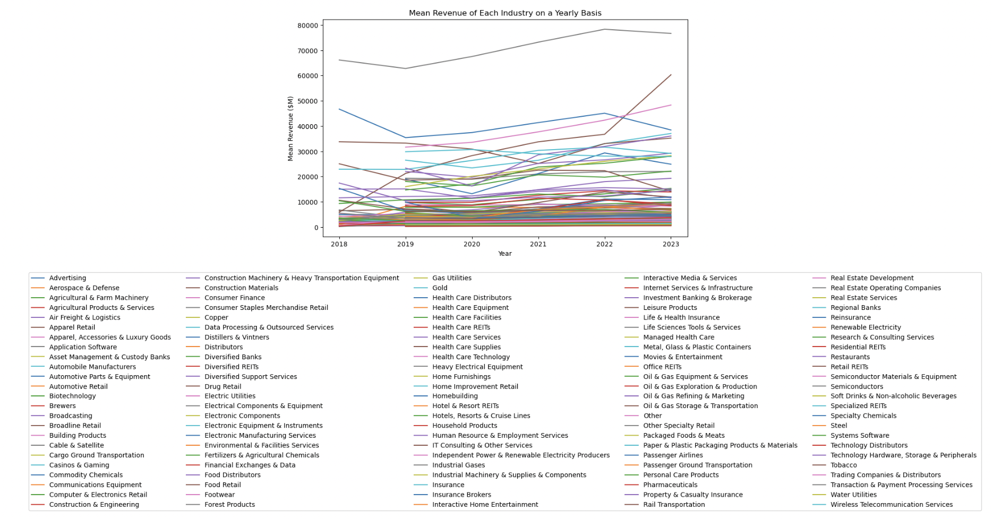

Figure 1.8: Box Plots for Each Variable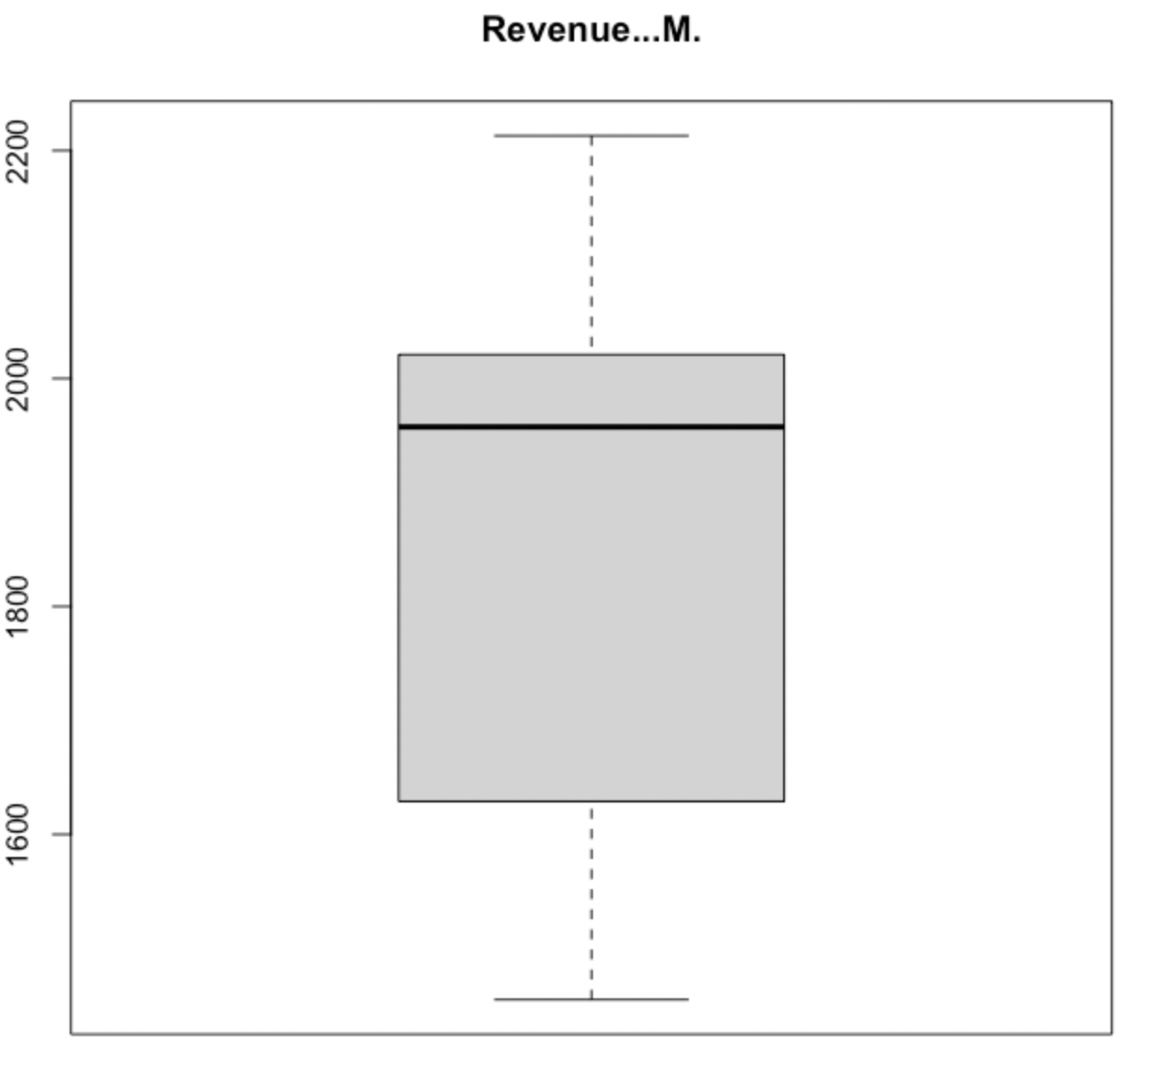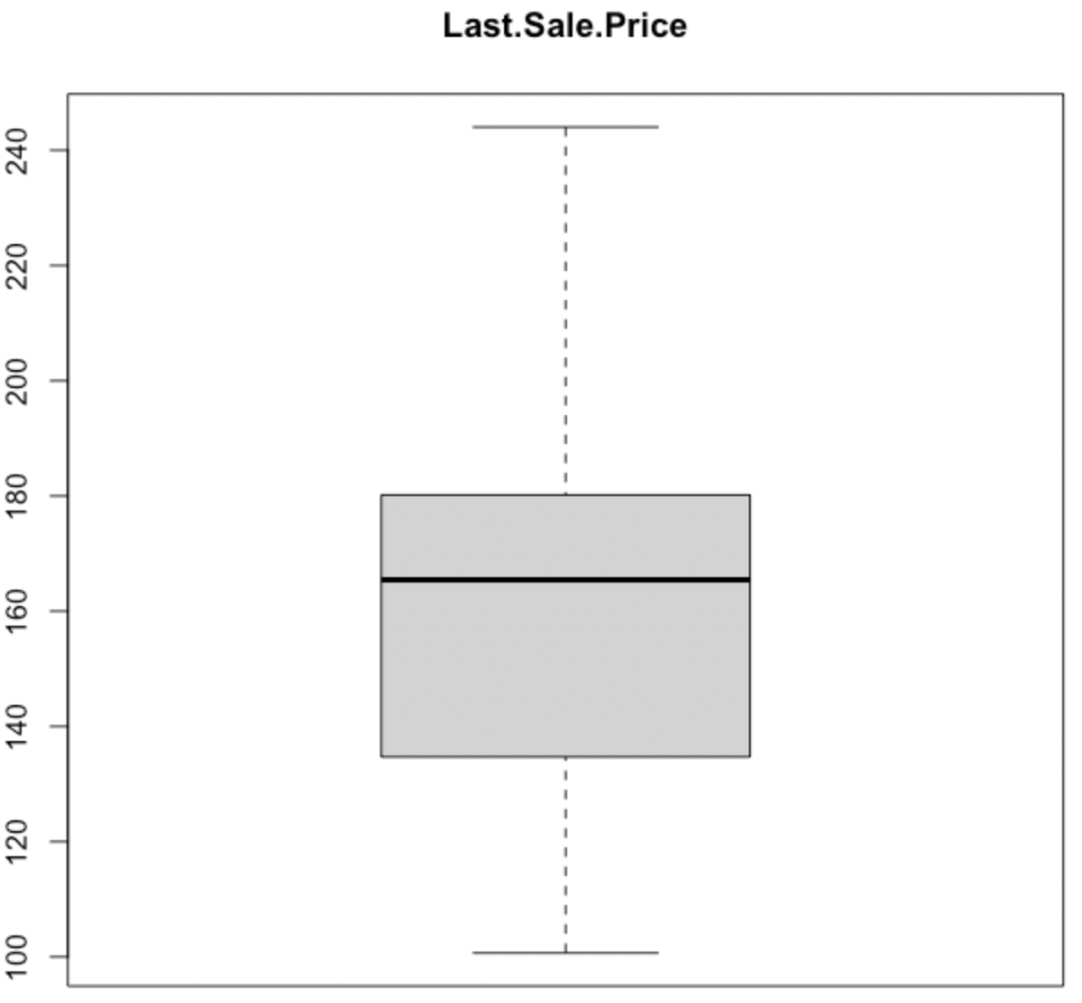

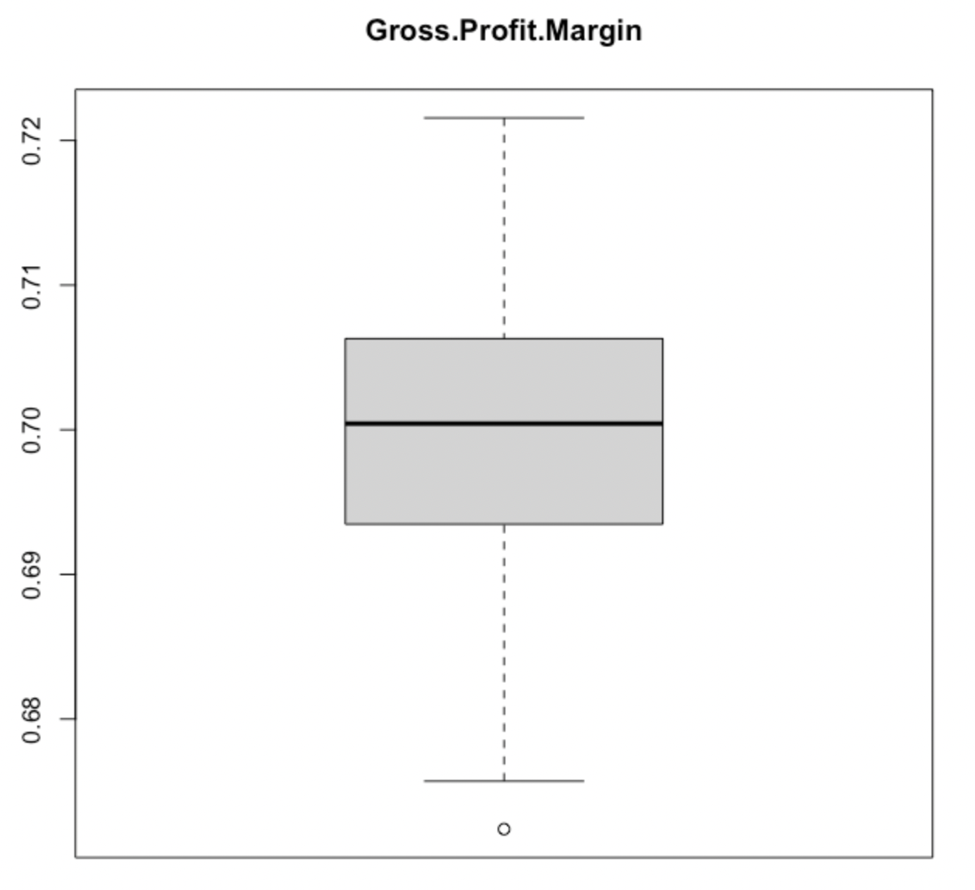

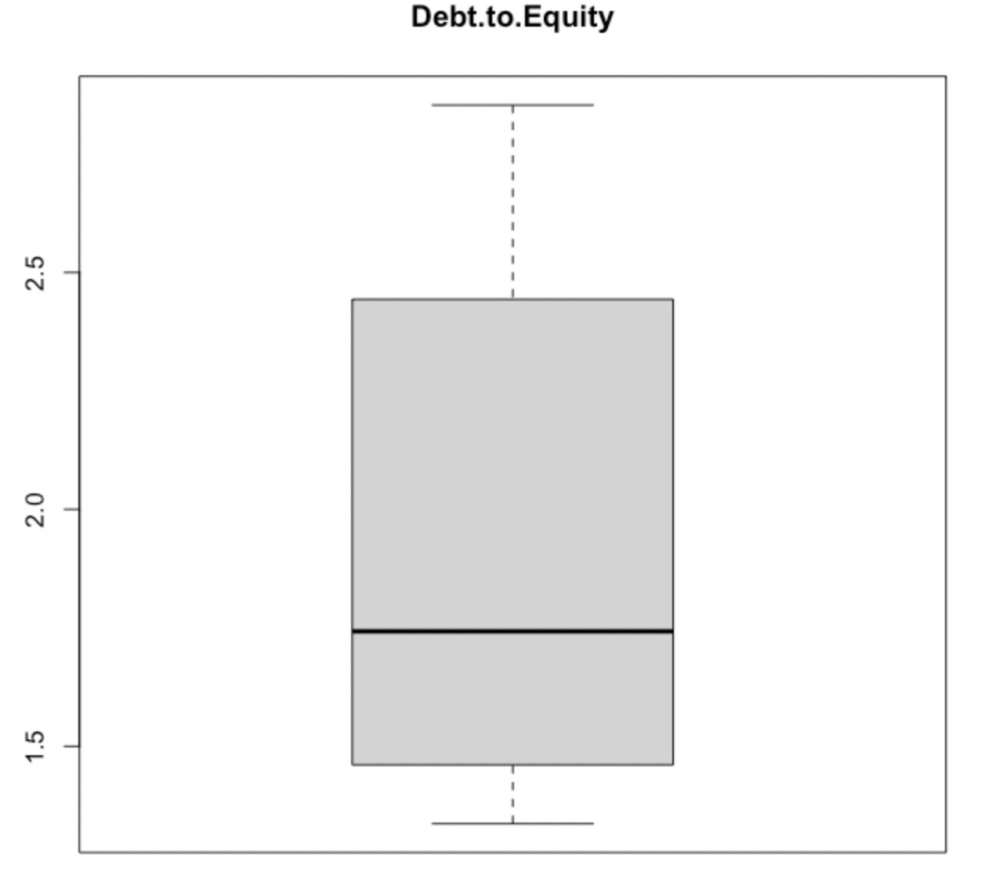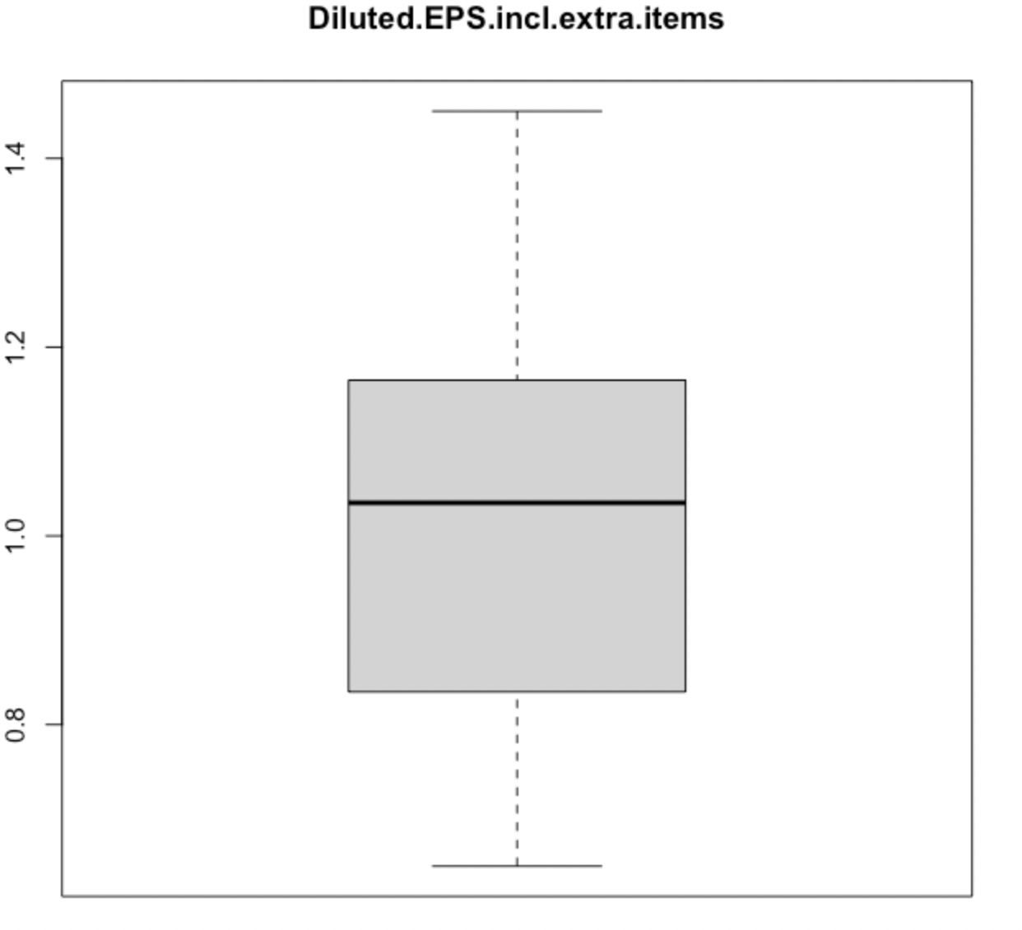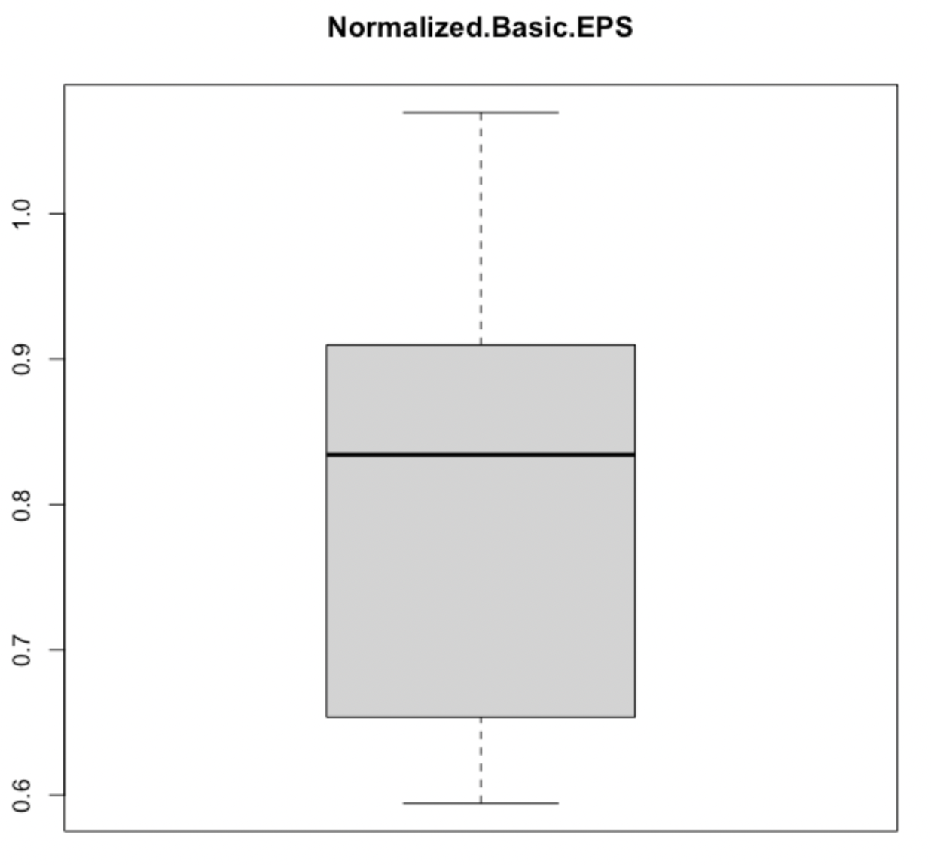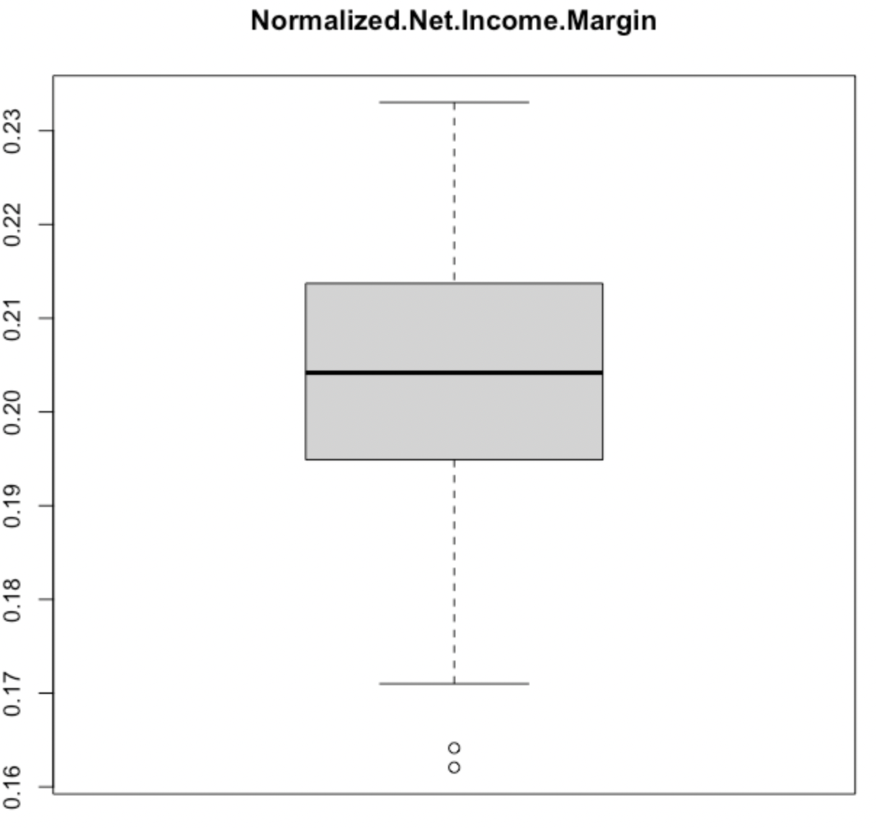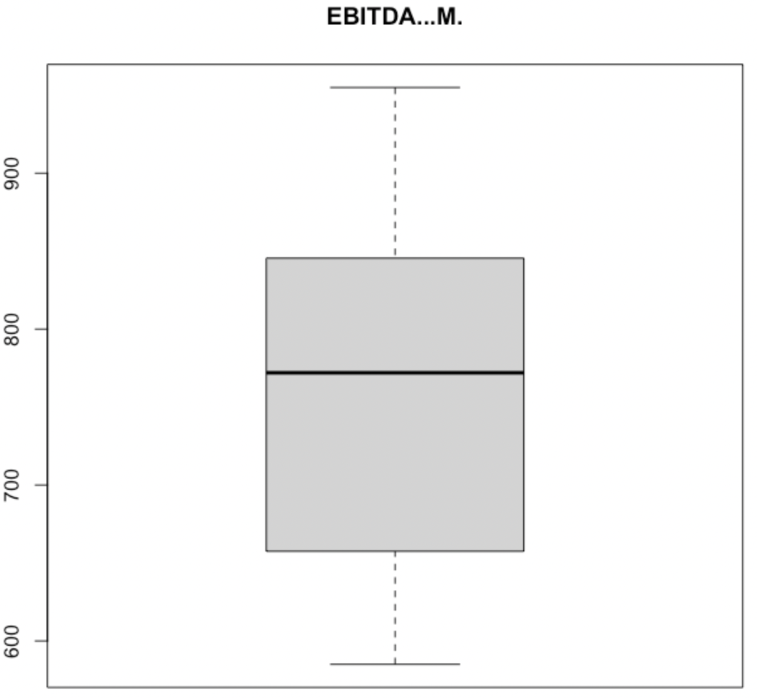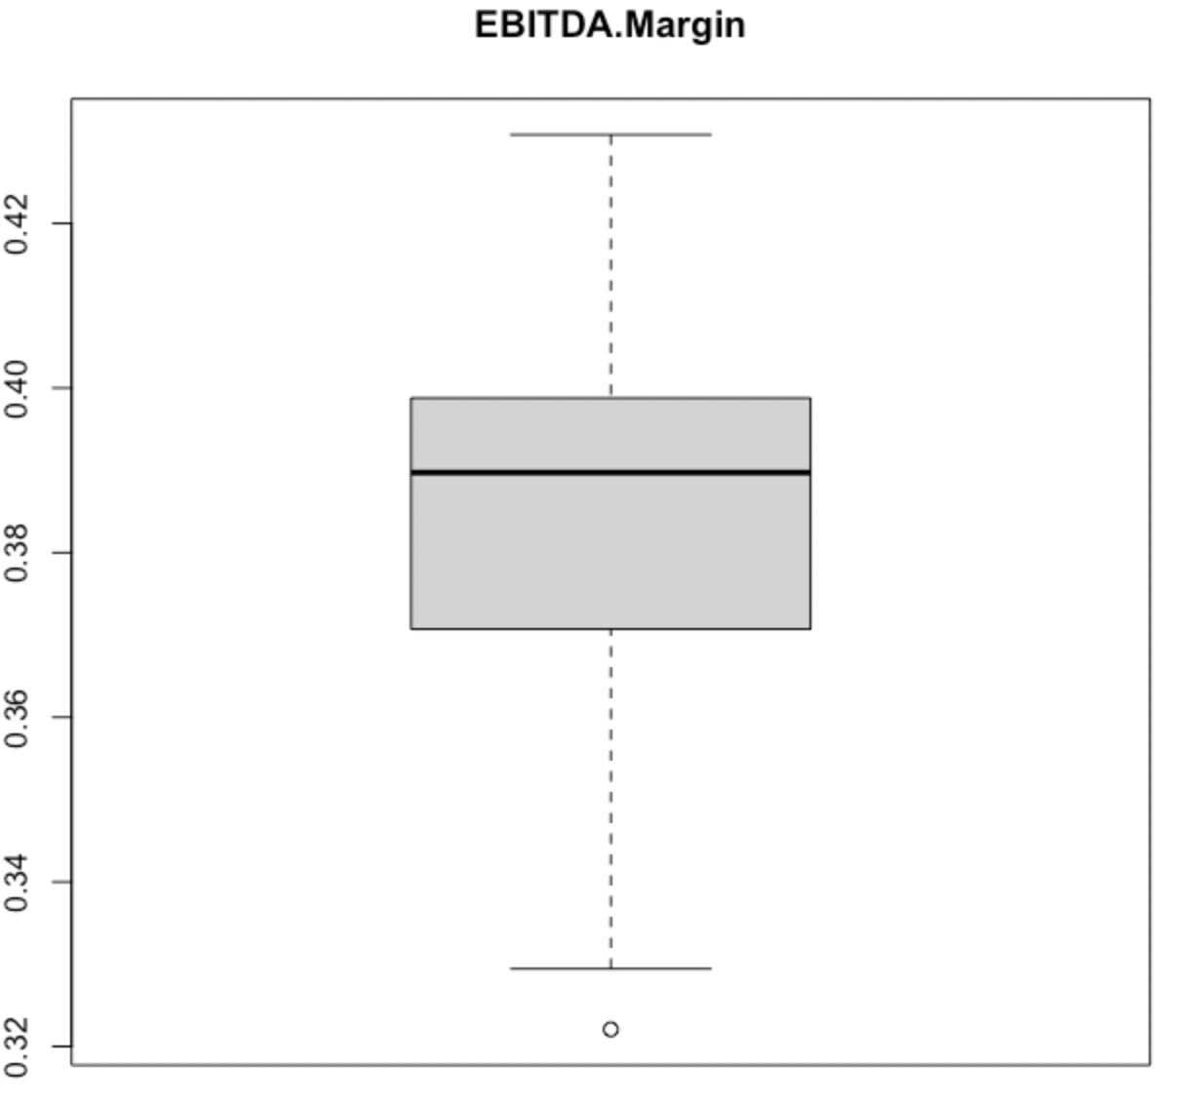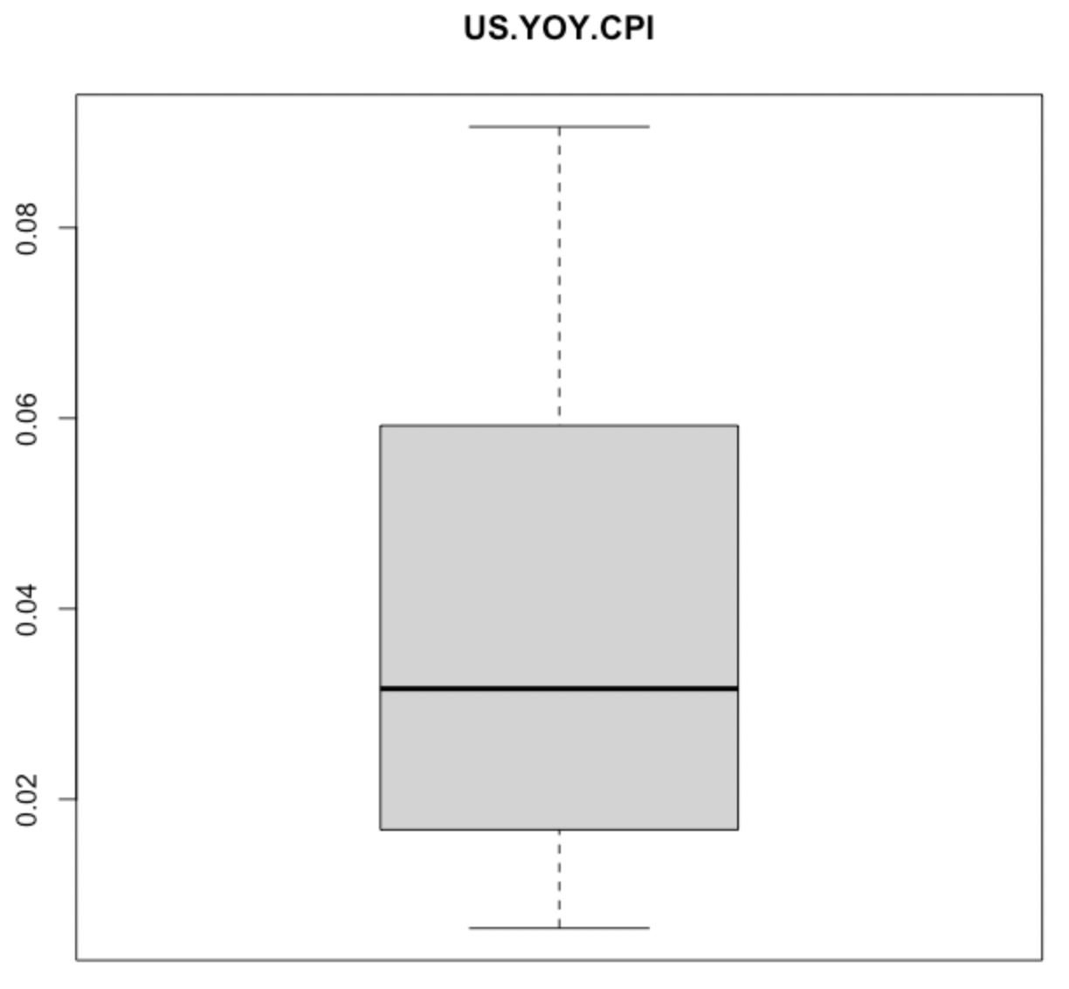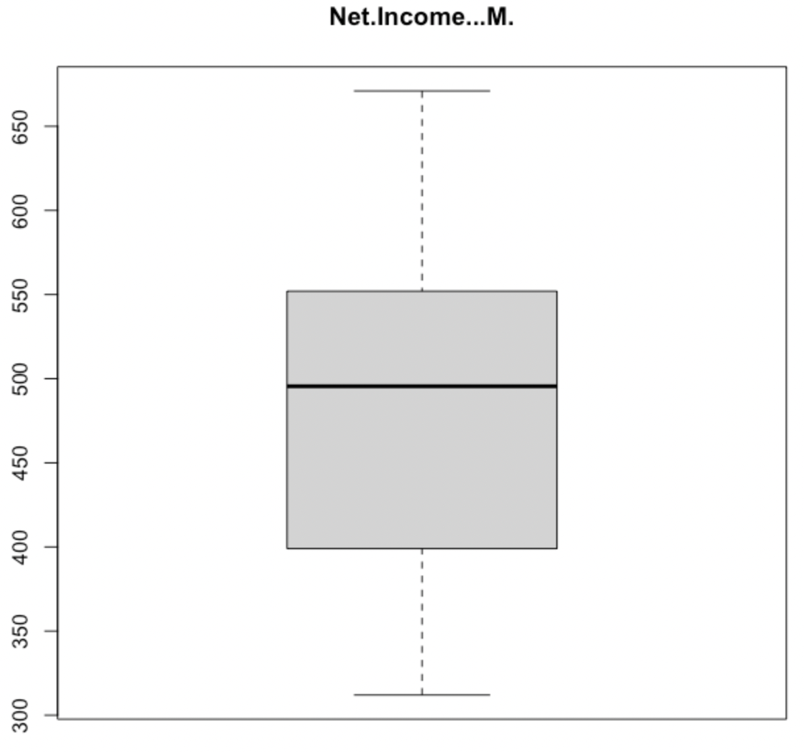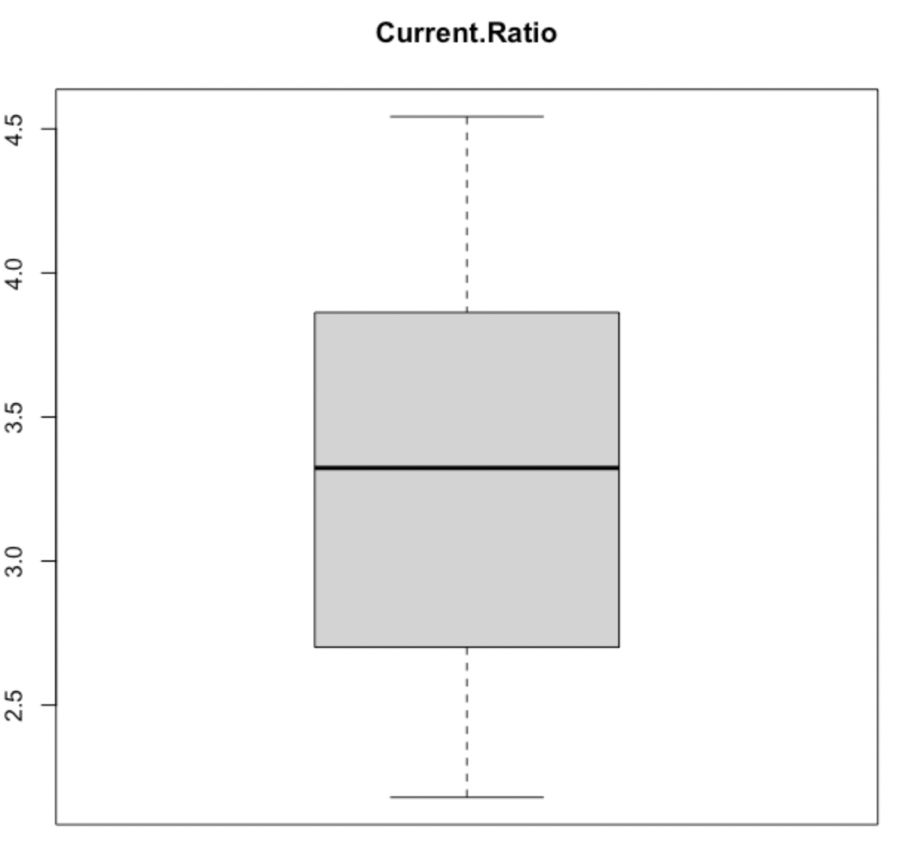

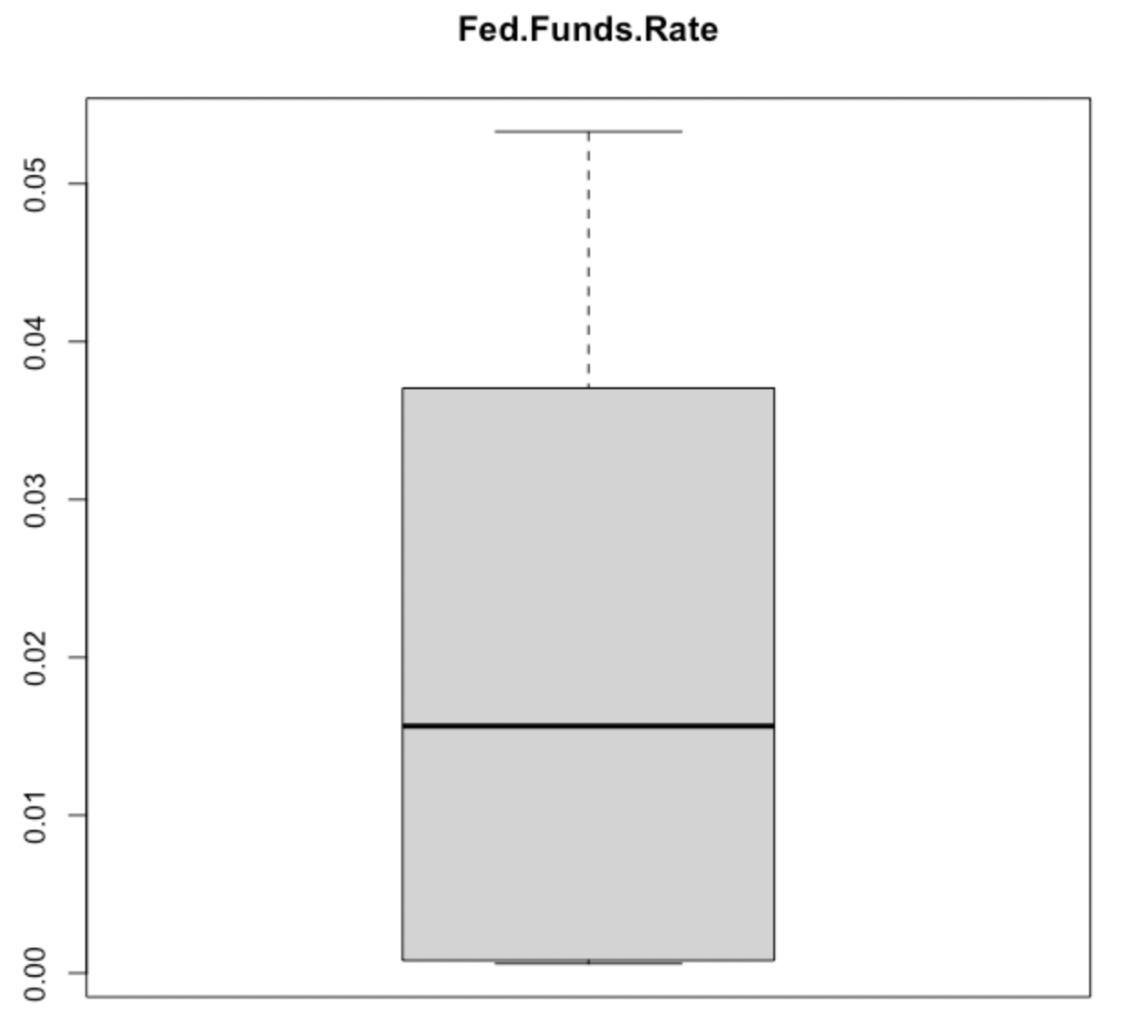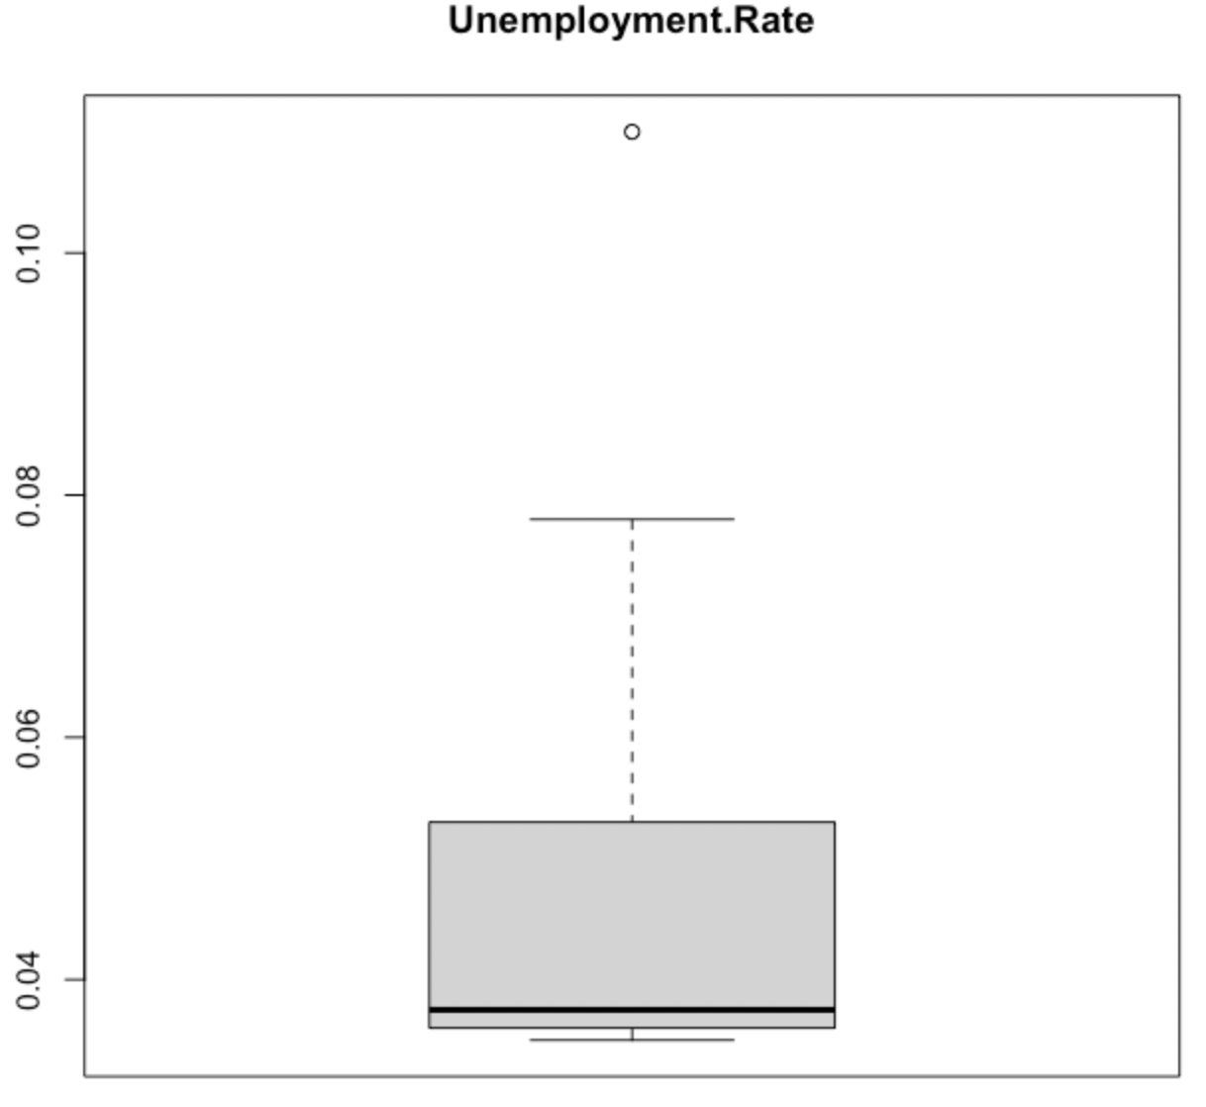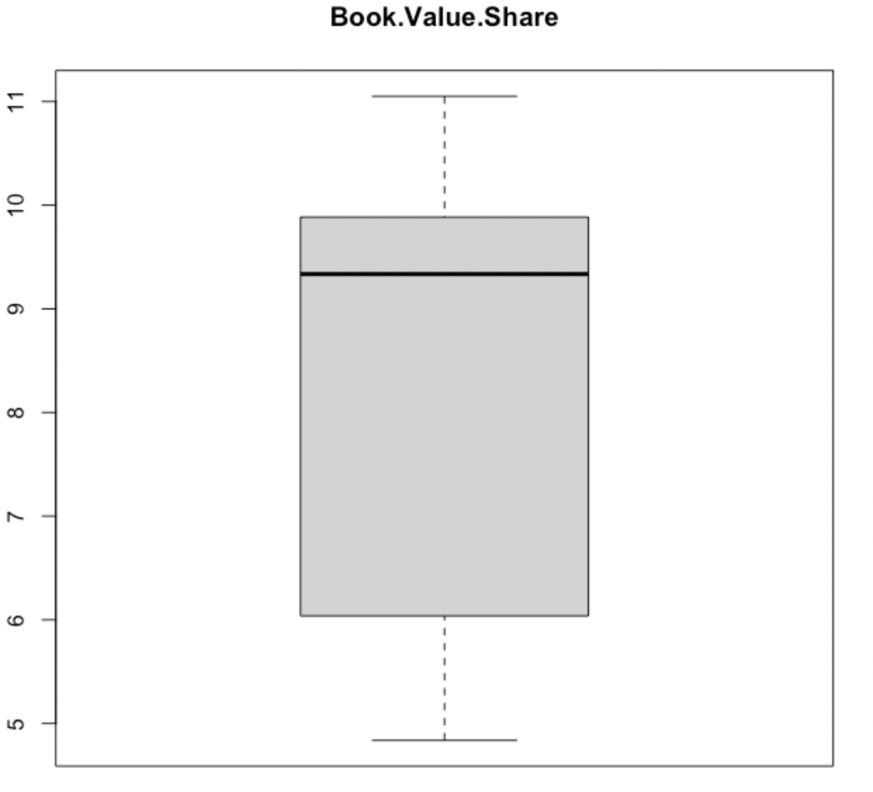

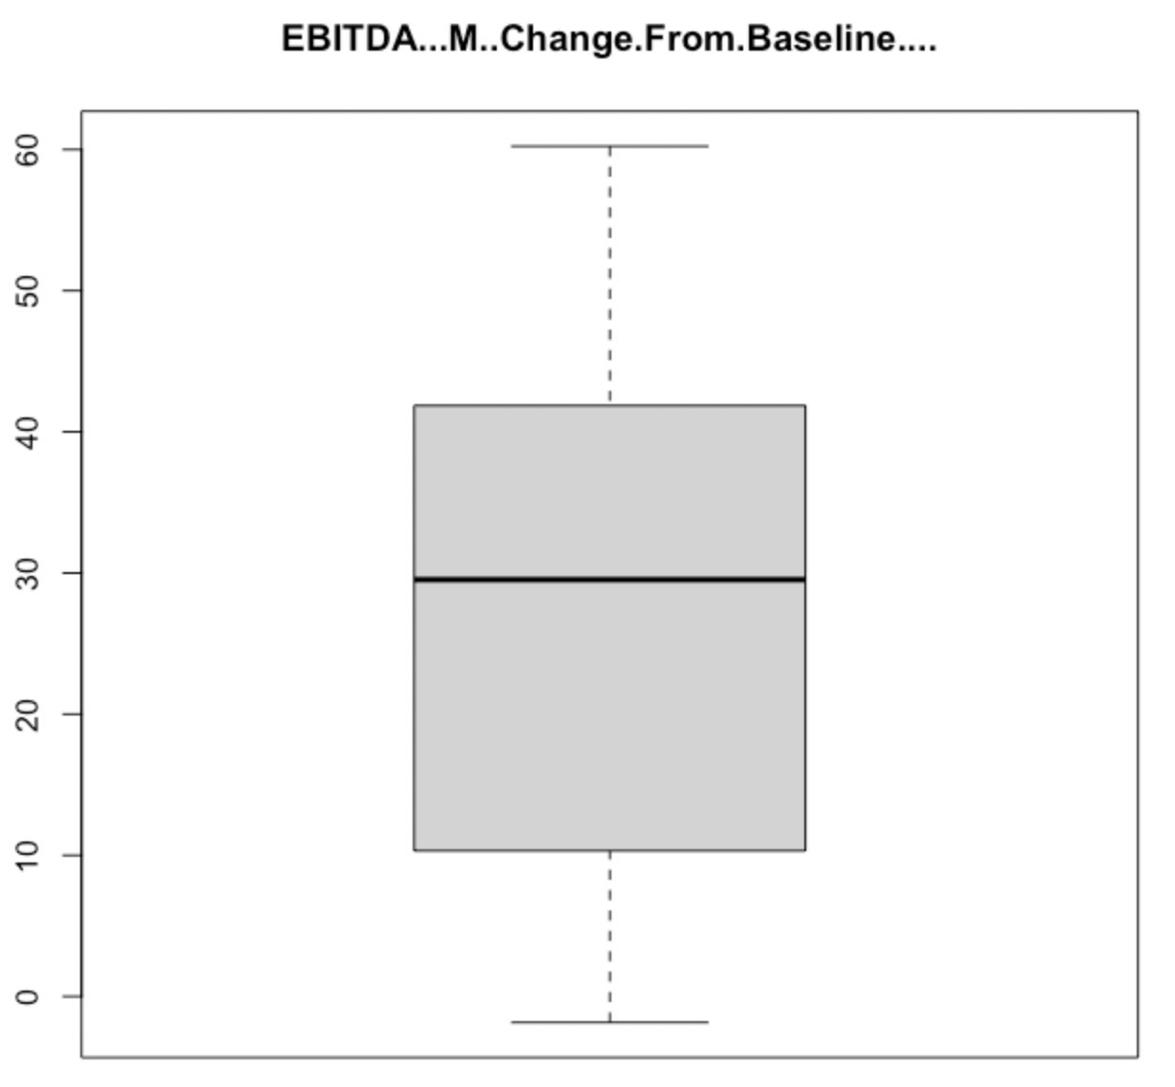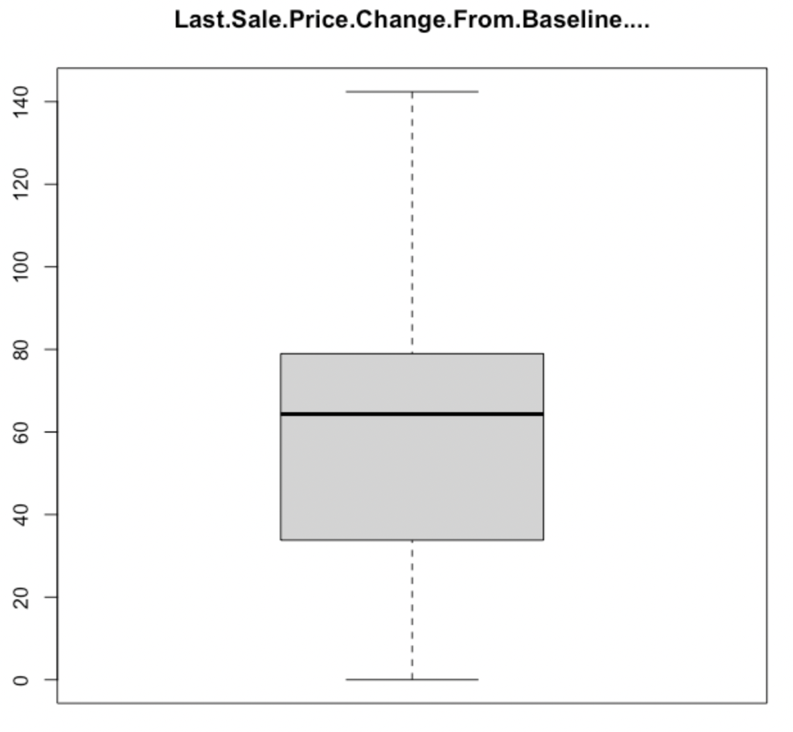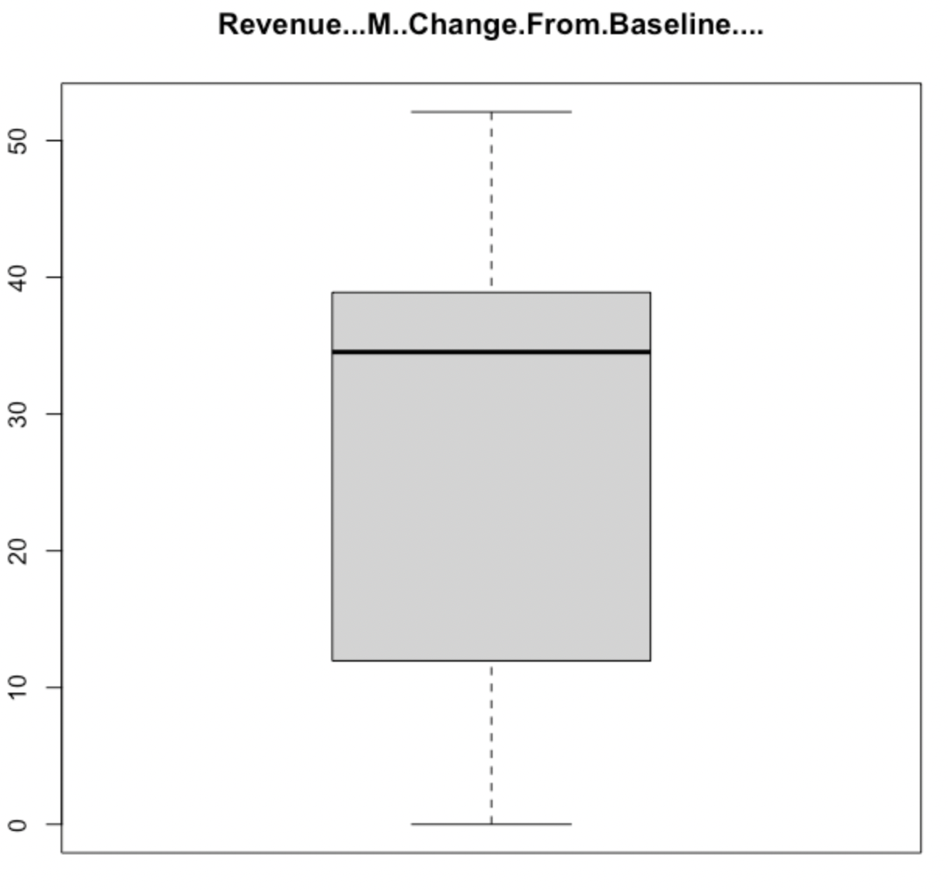

Figure 1.9: Final Model Fixed Effects

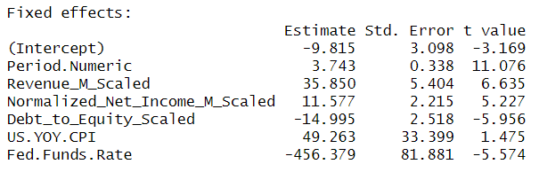

Figure 2.0: Correlation Plot between Last Sale Price and All Other Variables, Company 3M

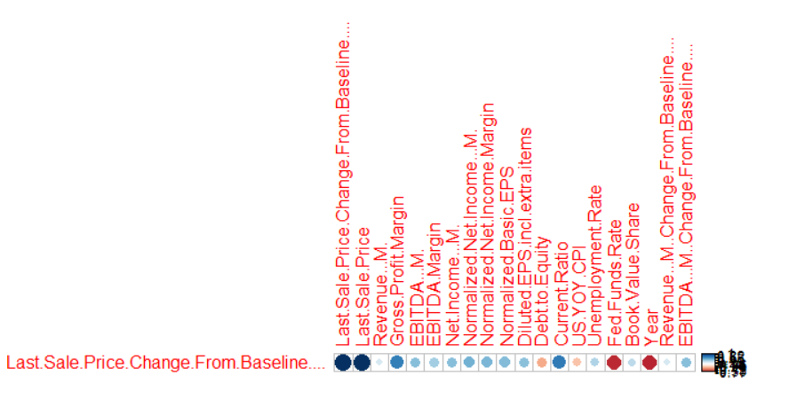

Figure 2.1: Correlation Plot between Last Sale Price and All Other Variables, All Companies Averaged

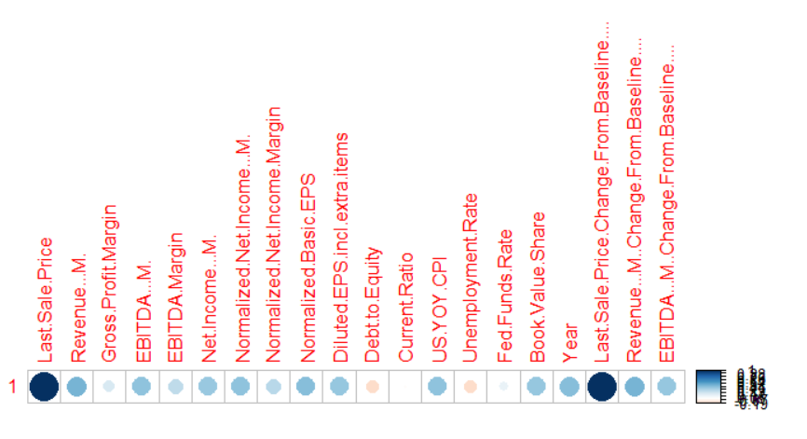

Figure 2.2: Final Model Random Effect Correlations

